**Emergency Information on Mobile**

Project Plan

By

Putchakarn Jaikon 542115031

Sawatdiporn Kitirot 542115065

Department of Software Engineering

College of Arts, Media and Technology

Chiang Mai University

Project Advisor

__________________________________

**Aj.Chartchai Doungsa-ard**

**Document History**

|  |  |  |  |  |  |  |
| --- | --- | --- | --- | --- | --- | --- |
| **Document Name** | **Details** | **Status** | **Date** | **Viewable** | **Reviewer** | **Responsible** |
| **Documents** | | | | | | |
| **EIOM-ProjectPlan-V.0.1.docx** | **Chapter 1**  •    Introduction  **Chapter 2**  •    Infrastructure | Draft | 2/4/2014 | PJ, SK, CD | PJ, SK | PJ, SK |
| **EIOM-ProjectPlan-V.0.2.docx** | **Chapter 3**  •    Management Procedures | Draft | 20/4/2014 | PJ, SK, CD | PJ, SK | PJ, SK |
| **EIOM-ProjectPlan-V.0.3.docx** | **Chapter 4**  •    Quality Plan | Draft | 27/4/2014 | PJ, SK, CD | PJ, SK | PJ, SK |
| **EIOM-ProjectPlan-V.0.4.docx** | **Chapter 5**  •    Estimated Duration of Tasks  **Chapter 6**  •    Estimated Effort and Cost | Draft | 30/4/2014 | PJ, SK, CD | PJ, SK | PJ, SK |
| **EIOM-ProjectPlan-V.0.5.docx** | **Chapter 7**  •    Identification of Project Risks  **Chapter 8**  •    Version Control Strategy | Draft | 2/5/2014 | PJ, SK, CD | PJ, SK | PJ, SK |
| **EIOM-ProjectPlan-V.0.6.docx** | •    Modify  - Introduction  - Infrastructure  - Management Procedures | Draft | 20/5/2014 | PJ, SK, CD | PJ, SK | PJ, SK |
| **EIOM-ProjectPlan-V.0.7.docx** | •    Modify  - Quality Plan  - Identification of Project Risks  - Version Control Strategy | Draft | 4/6/2014 | PJ, SK, CD | PJ, SK | PJ, SK |
| **EIOM-ProjectPlan-V.0.8.docx** | •    Add Table of content and cover page | Draft | 28/6/2014 | PJ, SK, CD | PJ, SK | PJ, SK |
| **EIOM-ProjectPlan-V.1.0.docx** | •    Modify  - Identification of Project Risks  •    Update Quality factory | Release | 28/6/2014 | PJ, SK, CD | PJ, SK | PJ, SK |
| **EIOM-ProjectPlan-V.1.1.docx** | •    Modify chapter 1 - 8 | Release | 30/7/2014 | PJ, SK, CD | PJ, SK | PJ, SK |
| **EIOM-ProjectPlan-V.2.0.docx** | •    Modify feature5, Configuration Item Table, Schedule Estimate Time | Release | 21/10/2014 | PJ, SK, CD | PJ, SK | PJ, SK |
| **EIOM-ProjectPlan-V.2.1.docx** | •    Change feature5 into feature6 | Release | 9/11/2014 | PJ, SK, CD | PJ, SK | PJ, SK |

PJ – Putchakarn Jaikon, SK – Sawatdiporn Kitirot, CD – Chartchai Doungsa-ard

Table of Contents

Chapter One | Introduction 4

1.1 Identification 4

1.2 Project Overview 4

1.3 Document Overview 4

1.4 Work Products to be Develop 6

1.5 Acronyms and Definitions 7

Chapter Two | Infrastructure 9

2.1 Software Development Life Cycle 9

2.2 Software Acquisition Plans 10

2.3 Hardware and Material Resources 10

Chapter Three | Management Procedures 11

3.1 Project Team Structure 11

3.2 Monitoring and Controlling Mechanism 11

3.2.1 Project Meeting 11

Chapter Four | Quality Plan 12

4.1 Quality Factors 12

4.2 Reviews/Responsibility 13

4.3 Testing 13

4.4 Software Development Standard 14

Chapter Five | Estimated Duration of Tasks 16

5.1 Schedule Estimate Time 16

Chapter Six | Estimated Effort and Cost 21

Chapter Seven | Identification of Project Risks 22

7.1 Risk Identification and Solutions 22

Chapter Eight | Version Control Strategy 23

8.1 Naming Conversion 23

8.2 Project Repository 24

8.3 Configuration Item Table 25

# Chapter One | Introduction

## Identification

The Project Management Plan is a document for planning, scheduling activities and evaluating overall of the project so that the project will complete as successfully as possible in spite of all the risks. The Project Management will lead us to see specific project reach fruition and allow us to work with it and see a project through from start to finish.

## Project Overview

Emergency Information on Mobile provides user’s application and administrator’s webpage. The application will show online map and offline map. User can views the information of each help place on the map and call directly from the application. The administrator webpage uses to manage the information such as add, edit information and delete help place out of the database.

* + 1. **Purpose & Scope**

Emergency Information on Mobile will support online map and offline map to help people about the information of the help pace. The application will provide the offline map with information around the user ten kilometers when they lost Internet connection.

## Document Overview

The purpose of the Emergency Information on Mobile project plan guide project team members during the development of Emergency Information on Mobile project.

**Progress Report I** consist of

**• Feature 5: Manage Information System**

**URS-01:** The administrator can add help place’s information, which includes name, address, district, province, zip code, phone number, category, latitude and longitude.

**URS-02:** The administrator can edit help place’s information, which includes name, address, district, province, zip code, phone number, category, latitude and longitude.

**URS-03:** The administrator can remove help place.

**URS-04:** The administrator can view help information of each help place.

**URS-05:** The administrator can browse the help place by category.

**URS-06:** The administrator can browse the help place by province of Thailand.

**URS-07:** The administrator can browse the help place by category and province of Thailand.

**• Feature 1: Map and Help Information System**

**URS-08:** The user can view the online map with their current location.

**URS-09:** The user can view the offline map with their current location.

**URS-10:** The user can view help places in online map.

**URS-11:** The user can view help places in offline map.

**URS-12:** The user can view help information of each help place in online map.

**URS-13:** The user can view help information of each help place in offline map.

**URS-14:** The user can make emergency call to each help place in online map.

**URS-15:** The user can make emergency call to each help place in offline map.

**Progress Report II** consist of

* **Feature 6: Support information for mobile**

**URS-16:** The mobile application can get list of all help places in the database.

**URS-17:** The mobile application can get the nearest help place by the selected category.

**URS-18:** The mobile application can get list of help places where locate in the setting scope.

* **Feature 2: Search information system**

**URS-19:** The user can search help place’s name by keyword in online map.

**URS-20:** The user can find the nearest help place by selection the category in online map.

* **Feature 4: Automatic collecting data system**

**URS-21:** The user can set the scope for downloading data.

**URS-22:** The mobile application can collect help place information automatically.

## Work Products to be Develop

**1.3.1Deliverable**

|  |  |  |  |  |
| --- | --- | --- | --- | --- |
| **No.** | **Deliverables/Release** | **Media** | **No. of Copies** | **Submit Date** |
| 1 | **Project Proposal** | Document | 3 | 6th March 2014 |
| • Emergency Information On Mobile |
| Version 1.0 |
| 2 | **Progress Report I** |  |  | 7th July 2014 |
| • Project Management Plan Version 1.0 | Document | 3 |
| • Software Requirement Specification | Document | 3 |
| Version 1.0 |  |  |
| • Software Design Document Version 1.0 | Document | 3 |
| • Test Plan Version 1.0 | Document | 3 |
| • Traceability Record Version 1.0 | Document | 3 |
| • Software Version 1.0 | Source Code | 1 |
| 3 | **Progress Report II** |  |  | 22rd Oct 2014 |
| • Project Management Plan Version 2.0 | Document | 3 |
| • Software Requirement Specification Version 2.0 | Document | 3 |
| • Software Design Document Version 2.0 | Document | 3 |
| • Test Plan Version 2.0 | Document | 3 |
| • Traceability Record Version 2.0 | Document | 3 |
| • Software Version 2.0 | Source Code | 1 |
|  |  |  |

|  |  |  |  |  |
| --- | --- | --- | --- | --- |
| 4 | **Final Progress** |  |  | 12th Dec 2014 |
| • Project Management Plan Version 3.0 | Document | 3 |  |
| • Software Requirement Specification Version 3.0 | Document | 3 |  |
| • Software Design Document Version 3.0 | Document | 3 |  |
| • Test Plan Version 3.0 | Document | 3 |  |
| • Traceability Record Version 3.0 | Document | 3 |  |
| • Show Pro Event |  |  | 19th Nov 2014 |
| -          30 second Video | Files | 1 |  |
| -          Poster size A1 | Poster | 1 |  |
| -          User manual | Files | 1 |  |
| • Software Version 3.0 | Source Code | 1 |  |
| • Software Source Code | CD-ROM | 1 | 19rd Dec 2014 |

## Acronyms and Definitions

**1.5.1 Acronyms**

EIOM Emergency Information on Mobile

SRS Software Requirement Specification

URS User Requirement Specification

**1.5.2 Definition**

|  |  |
| --- | --- |
| Acceptance Test | Test activities for sample checks to verify that a system (or product, solution) has the right quality for development or usage. Often acceptance test is done by the customer. [IEEE90] |
| Feature | Transformation of input parameters to output parameters based on a specified algorithm. It describes the functionality of a product. Used for requirements analysis, design, coding, testing or maintenance. [IEEE90] |
| IEEE | Institute for Electrical and Electronics Engineers. Biggest global interest group for engineers of different branches and for computer scientists. [IEEE90] |
| Plan | A documented series of tasks requires meeting an objective, typically including the associated schedule, budget, resources, organizational description and work breakdown structure. [IEEE90] |
| Project Management | The application of knowledge, skills, tools, and techniques to project activities in order to meet or exceed stakeholder needs and expectations from a project. [IEEE90] |
| Project plan | A formal, approved document used to guide both project execution and project control. The primary uses of project plan are to document planning assumptions and the decision, to facilitate communication among stakeholders, and to document approved scope, cost, and schedule baseline. [IEEE90] |
| Risk | An uncertain event or condition that, if it occurs, has a positive or negative effect on a project's objectives. It is a function of a probability of occurrence of a given threat's occurrence. [IEEE90] |
| Risk Management | The systematic application of management policies, procedures and practices to the tasks of identifying, analyzing, evaluating, treating and monitoring risk. [IEEE90] |
| Traceability | The ability to trace the history, application or location of an item or activity, or work products or activities, by means of recorded identification. The establishment and maintenance of relationships between such items. Horizontal traceability describes the relationship between work products of same type (e.g., customer requirements). Vertical traceability describes the relationship between work products which build upon each other or are derived from each other (e.g., from customer requirements to qualification test cases). Bidirectional traceability allows to directly following relationships in both directions. [IEEE90] |
| Unit test | A test of individual programs or modules in order to remove a design or programming errors. [IEEE90] |

# Chapter Two | Infrastructure

## 2.1 Software Development Life Cycle

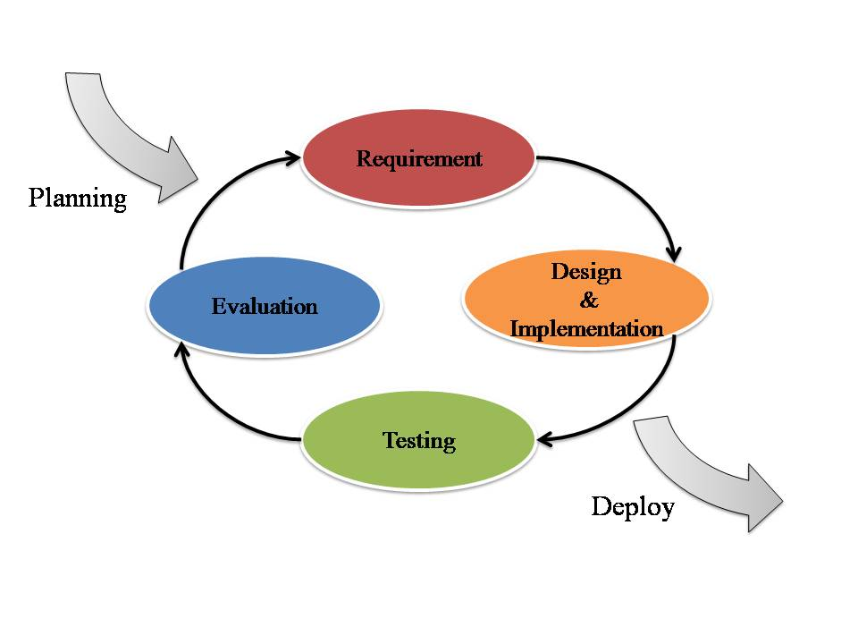

**Figure 1 Iterative Development Model**

Figure 1 presents a method of software development. Iterative development model is a cyclic software development process developed in response to the weaknesses of the Waterfall model. The model starts with planning and continues through iterative development cycles.

Emergency Information on Mobile uses Iterative Development Model. Developer can use model to develop the iterative way to fulfill, change software and document for each development process.

## 2.2 Software Acquisition Plans

**2.2.1 Design Tools**

* Photoshop CS6
* Adobe Dreamweaver CS6

**2.2.2 Development Tools**

* Eclipse Kepler
* IntelliJ 12.1.6

**2.2.3 Configuration Management Tools**

* GitHub

**2.2.4 Document Tools**

* Microsoft Word 2013

**2.2.5 Testing Tools**

* Smart Phone Samsung (Android Device)
* Notebook with Google chrome or Firefox browser
* Host Server

## Hardware and Material Resources

* **Internet**
* **Computers**
  + Apple Macbook Pro mid 2013
    - Processor: Intel® Core™ i7-3520M CPU @ 2.90GHz 2.90GHz
    - RAM: 8.00 GB
    - Operating System: Windows 7 Ultimate
  + Dell Inspiron n5110
    - Processor: Intel® Core™ i5-2410M CPU @ 2.30GHz 2.30GHz
    - RAM: 4.00 GB
    - Operating System: Windows 7 Ultimate
* **Mobile phones:** Android Operating System
  + Samsung Galaxy Grand 2 SM-G7102
    - CPU: Quad-core 1.2 GHz Cortex-A7
    - RAM: 1.5 GB
    - Operating System: Android OS, v4.3 (Jelly Bean)
  + Samsung Galaxy S DUOS
    - CPU: 1GHz Cortex-A5
    - RAM: 768 MB
    - Operating System: Android OS, v4.04 (Ice Cream Sandwich)

# Chapter Three | Management Procedures

## 3.1 Project Team Structure

|  |  |
| --- | --- |
| **Roles** | **Responsibility** |
| **Developer** | •         Create document |
|  | - Proposal |
|  | - Project Plan |
|  | - SRS |
|  | - Software Design Document |
|  | •         Develop software |
| **Tester** | •         Create document |
|  | - Test Plan |
|  | - Test Record |
|  | - Traceability Record |
|  | •         Test software |
| **Reviewer** | •         Review document and software |
|  | •         Manage change |

|  |  |
| --- | --- |
| **Participants** | **Roles** |
| Sawatdiporn Kitirot | **Server Part**: Developer, Tester and Reviewer |
| Putchakarn Jaikon | **Mobile Part**: Developer, Tester and Reviewer |

## 3.2 Monitoring and Controlling Mechanism

### 3.2.1 Project Meeting

|  |  |
| --- | --- |
| **Participants** | **Roles** |
| Aj.Chartchai Doungsa-ard | Project Advisor |
| Putchakarn Jaikon | Development team member |
| Sawatdiporn Kitirot | Development team member |

# Chapter Four | Quality Plan

## 4.1 Quality Factors

**Product operation factors**

* **Correctness**
* A software product should be able to provide correctness information of help places more than 80% of data.
* **Reliability**
* The software should be able to handle more than 80% of traditional activity with less than 10% of software’s failure.
* **Usability**
* The person who uses software product, as his first time should be able to estimate complacency of the product. The estimate complacency of the user to the product should more than 70 %.

**Product revision factors**

* **Testability** 
  + - The software should be able to be tested 100% of it defined routine and functionality.

**Product transition factors**

* **Reusability** 
  + - More than 20% part of finished software product should be able to be reused in future development.

## 4.2 Reviews/Responsibility

|  |  |  |  |
| --- | --- | --- | --- |
| **Stage Exit Review** | | | |
| **No.** | **Stage** | **Review Item** | **Responsibility** |
| 1 | Project Planning | Project Plan | Putchakarn, Sawatdiporn |
| 2 | Requirement   Specification | Software Requirement Specification | Putchakarn, Sawatdiporn |
| 3 | Architecture and   Detailed Design | Software Design Document | Putchakarn, Sawatdiporn |
| 4 | Software Testing | Software Testing Documents | Putchakarn, Sawatdiporn |
| 5 | Project Monitoring  and Control | Traceability Record | Putchakarn, Sawatdiporn |

## 4.3 Testing

|  |  |  |
| --- | --- | --- |
| **Test Process** | | |
| **No.** | **Test** | **Responsibility** |
| 1 | **Unit Testing**   * Feature 5, 6 (Server Part) * Feature 1, 2, 3, 4 (Mobile Part) | Sawatdiporn  Putchakarn |
| 2 | **System Testing** | Putchakarn, Sawatdiporn |
| 3 | **Acceptance Testing** | Putchakarn, Sawatdiporn |

## 

## 4.4 Software Development Standard

**4.4.1 ISO29110 for Very Small Entity (VSE)**

ISO 29110 is a guide applies to Very Small Entities (VSEs), enterprise, organization, department or project up to 25 people, dedicated to software development. The Guide provides Project Management and Software Implementation process which integrate practices based on the selection of ISO/IEC12207- Systems and Software Engineering –Software Life Cycle process – guidelines for the content of software life cycle process information products (documentation) standards elements.

1. **Project Management (PM) process** 
   * **PM purpose**

The purpose of the Project Management process is to establish and carry out in a systematic way the tasks of the software implementation project, which allows complying with the project’s objectives in the expected quality, time and costs.

* + **PM objectives**

**PM.O1:** The *Project Plan* for the execution of the project is developed according to the *Statement of Work* and validated with the Customer. The tasks and resources necessary to complete the work are sized and estimated

**PM.O2:** Progress of the project is monitored against the *Project Plan* and recorded in the *Progress Status Record.* Corrections to remediate problems and deviations from the plan are taken when project targets are not achieved. Appropriate treatment is taken to correct or avoid the impact of risk. Closure of the project is performed to get the Customer acceptance documented in the *Acceptance Record*.

**PM.O3:** The *Change Requests* are addressed through their reception and analysis. Changes to software requirements are evaluated for cost, schedule and technical impact.

**PM.O4:** Review meetings with the Work Team and the Customer are held. Agreements are registered and tracked.

**PM.O5:** *Risks* are identified as they develop and during the conduct of the project.

**PM.O6:** A software *Version Control Strategy* is developed. Items of *Software Configuration* are identified, defined and base lined. Modifications and releases of the items are controlled and made available to the Customer and Work Team including the storage, handling and delivery of the items.

* + - 1. Set rule for managing the version control.
      2. Identify time for update version control.
      3. Record change of each version in version control table.

**PM.O7:** Software Quality Assurance is performed to provide assurance that work products and processes comply with the *Project Plan* and *Requirements Specification*

* + **PM Activities**

The Project Management Process has the following activities:

* + - PM.1 Project Planning
    - PM.2 Project Plan Execution
* PM.3 Project Assessment and Control
* PM.4 Project Closure

**2. Software Implementation (SI) process**

* + **SI purpose**

The purpose of the Software Implementation process is the systematic performance of the analysis, design, construction, integration and tests activities for new or modified software products according to the specified requirements.

* + **SI objectives**

**SI.O1:** Tasks of the activities are performed through the accomplishment of the current *Project Plan*.

**SI.O2:** Software requirements are defined, analyzed for correctness and testability, approved by the Customer, base lined and communicated.

**SI.O3:** Software architectural and detailed design is developed and base lined. It describes the software items and internal and external interfaces of them. Consistency and traceability to software requirements are established.

**SI.O4:** Software components defined by the design are produced. Unit test are defined and performed to verify the consistency with requirements and the design. Traceability to the requirements and design are established.

**SI.O5:** *Software* is produced performing integration of software components and verified using *Test Cases and Test Procedures*. Results are recorded at the *Test Report*. Defects are corrected and consistency and traceability to *Software Design* are established.

**SI.O6:** A *Software Configuration* that meets the Requirements Specification as agreed to with the Customer, which includes user, operation and maintenance documentations, is integrated, base lined and stored at the *Project Repository*. Needs for changes to the *Software Configuration* are detected and related *Change Requests* are initiated.

**SI.O7:** Verification and Validation tasks of all required work products are performed using the defined criteria to achieve consistency among output and input products in each activity. Defects are identified, and corrected; records are stored in the *Verification/Validation Results*.

* + **SI activities**

The Software Implementation Process has the following activities:

* SI.1 Software Implementation Initiation
* SI.2 Software Requirements Analysis
* SI.3 Software Architectural and Detailed Design
* SI.4 Software Construction
* SI.5 Software Integration and Tests
* SI.6 Product Delivery

# Chapter Five | Estimated Duration of Tasks

## 5.1 Schedule Estimate Time

|  |  |  |  |
| --- | --- | --- | --- |
| **Feature** | **Name** | **User Requirement Specification** | **Plan Date** |
| **Name** |
| #1. | Map and help information system | The user can view the online map with their current location. | 07/04/14 - 12/04/14 |
| The user can view the offline map with their current location. | 18/04/14 - 23/04/14 |
| The user can view help places in online map. | 24/04/14 - 30/04/14 |
| The user can view help places in offline map. | 24/04/14 - 30/04/14 |
| The user can view help information of each help place in online map | 01/05/14 - 14/05/14 |
| The user can view help information of each help place in offline map | 15/05/14 - 30/05/14 |
| The user can make emergency call to each help place in online map | 31/05/14 - 15/06/14 |
| The user can make emergency call to each help place in online map | 31/05/14 - 15/06/14 |
| #2. | Search information system | The user can search help place’s name by keyword in online map. | 22/07/14 - 21/10/14 |
| The user can find the nearest help place by selection the category in online map | 22/07/14 - 21/10/14 |
| #3. | Rating location | The user can rate the help place. | 29/10/14 – 18/12/14 |
| The user can view average rating score of each help place in online map. | 29/10/14 – 18/12/14 |
| The user can view average rating score of each help place in offline map. | 29/10/14 – 18/12/14 |
| The user can update rating score. | 29/10/14 – 18/12/14 |
| #4. | Automatic collecting data system | The user can set the scope for downloading data. | 22/07/14 - 21/10/14 |
| The mobile application can collect help place information automatically | 22/07/14 - 21/10/14 |
| **Feature** | **Name** | **User Requirement Specification** | **Plan Date** |
| **Name** |
| #5. | Manage information system | The administrator can add help place’s information, which includes name, address, district, province, zip code, phone number, category, latitude and longitude. | 07/04/14 - 20/04/14 |
| The administrator can edit help place’s information, which includes name, address, district, province, zip code, phone number, category, latitude and longitude. | 20/04/14 - 01/05/14 |
| The administrator can remove help place. | 02/05/14 - 09/05/14 |
| The administrator can view help information of each help place. | 10/05/14 - 20/05/14 |
| The administrator can browse the help place by category. | 20/05/14 - 02/06/14 |
| The administrator can browse the help place by province of Thailand. | 20/05/14 - 02/06/14 |
| The administrator can browse the help place by category and province of Thailand. | 03/06/14 - 15/06/14 |
| #6. | Support information for mobile | The mobile application can get list of all help places in the database. | 22/07/14 - 21/10/14 |
| The mobile application can get the nearest help place by the selected category. | 22/07/14 - 21/10/14 |
| The mobile application can get list of help places where locate in the setting scope. | 22/07/14 - 21/10/14 |

**Feature: #1 - #4 (Mobile Part)**

**Feature: #5 - #6 (Server Part)**

**Progress Report I**

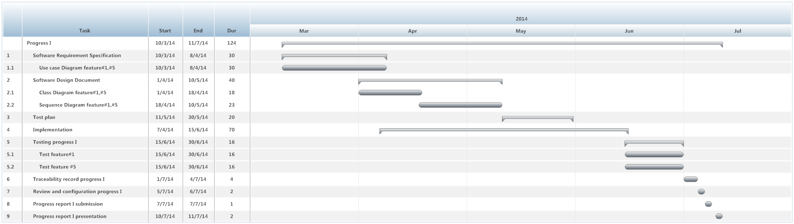

**Figure 2 Milestone of Progress Report I**

Figure 2 shows estimated duration of tasks in the progress report I

**Progress Report II**

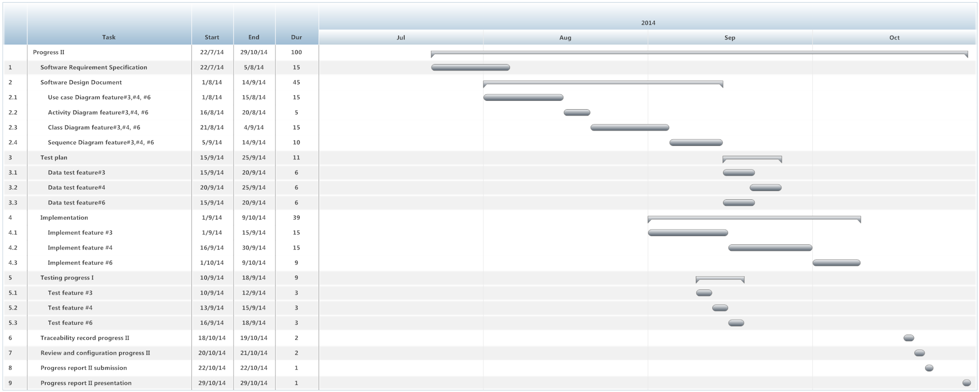

**Figure 3 Milestone of Progress Report II**

Figure 3 shows estimated duration of tasks in the progress report II

**Progress Report III**

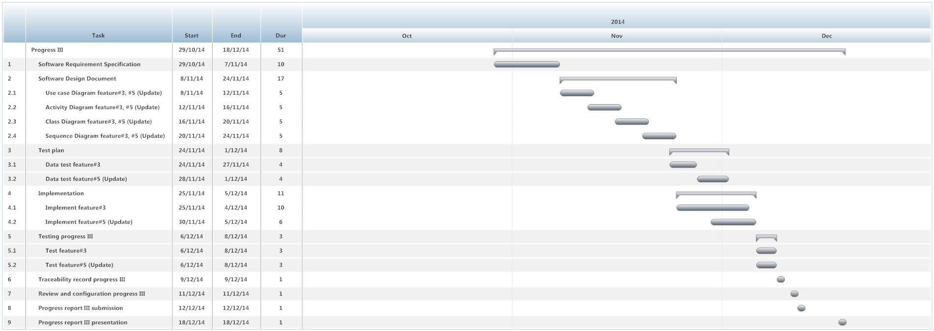

**Figure 4 Milestone of Progress Report III**

Figure 4 shows estimated duration of tasks in the progress report III

# Chapter Six | Estimated Effort and Cost

|  |  |
| --- | --- |
| **Item** | **Approximately Cost (THB)** |
| Android Programming Textbook | 1,000 |
| Print cost of software document (ink and paper) | 2,000 |
| Printer | 1,500 |

Emergency Information on Mobile application is supported by College of Arts, Media and Technology, Chiang Mai University as a senior project. The faculty will provide 500 THB for poster presentation, and will provide hardware for development.

# Chapter Seven | Identification of Project Risks

# **7.1 Risk Identification and Solutions**

|  |  |
| --- | --- |
| **Risk** | **Solution** |
| Group members lack skill and knowledge | - Need to study and training time for group members.  - Discuss with people who have knowledge about topic which is required for development. |
| The deliverables may be delay | - Working base on schedule.  - Study hard with our project to decrease the risk about time for developing program. |
| Computer crash and document has been lost from developer’s computer | - Need to use version control version software like, GitHub to store the document.  - Team member always updates file into GitHub. |

# Chapter Eight | Version Control Strategy

## 8.1 Naming Conversion

For naming conversion of Emergency Information on Mobile project, the name of document and software will be named as following format:

“[Project Name]-[Document Name]-[Version].[File Type]”

* **Project Name**

This part will be the name of this project that is “EIOM”

* **Document Name**

This part will depend on substance of that file. In each file will has its certain name as following:

* Proposal
* Project Plan & Quality Plan
* Software Requirement Specification (SRS)
* Software Design Document (SDD)
* Coding
* Test Plan
* Test Record
* Traceability Record (TR)
* **Version**

This part is the version of document. Version number will be in the following format:

“V.[Main version].[Sub version]”

* Main version is the main of version software and document. For example V.1.0, the number 1 is the main version. It might refer to feature of software.
* Subversion is a part of main for developing. Subversion will has to update more than the main version.
* **File Type**

This part is the type of file or the file extension. For example, .docx, .pdf.

## Project Repository

**• GitHub**

GitHub is a tool that can help to manage the version of document and software. Developers can share file or update version of the file anytime that they want. Developers have to have their own account of GitHub. Then the developers can create a project file and can share it with anyone they want.

For Emergency Information on Mobile project, we will create folders to be the project repository as following:

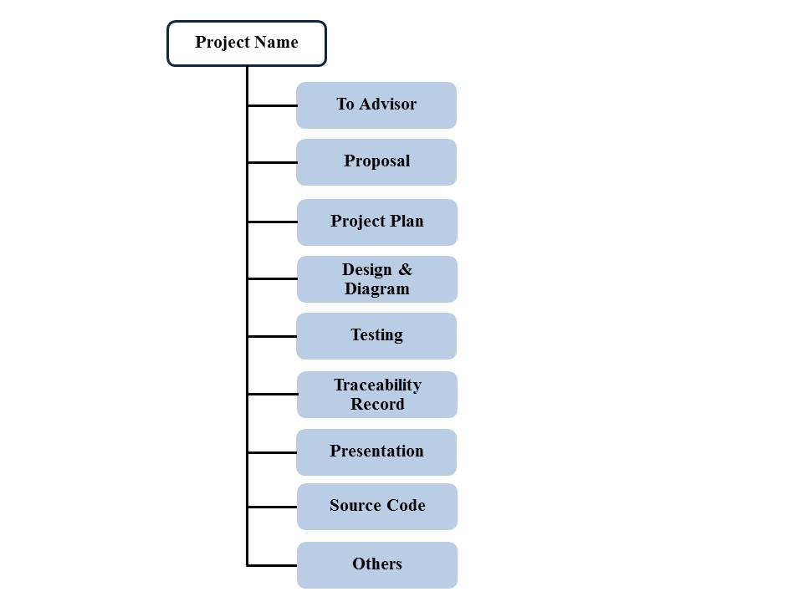

**Figure 5 Repository of Emergency Information on Mobile project**

**List of related document and description**

* To Advisor: contain document files that will be waiting to be reviewed by advisor.
* Proposal: contain involving proposal files.
* Project plan: contain project plan document files.
* Design & Diagram: contain design and diagram document files.
* Testing: contain testing document files.
* Traceability record: contain traceability record document
* Presentation: contain presentation files.
* Source code: contain source code of project.
* Others: contain kind of picture, server information, interesting web site and etc.

## Configuration Item Table

| **No.** | **Item** | **File name** | **File Type** | **Owner** | **Path** | **Baseline version** |
| --- | --- | --- | --- | --- | --- | --- |
| 1. | Project Proposal | EIOM-ProjectProposal-V.1.2 | .docx | Putchakarn, Sawatdiporn | /EIOM /Proposal | 1.2 |
| 2. | Project Plan | EIOM-ProjectPlan-V.2.1 | .docx | Putchakarn, Sawatdiporn | /EIOM /Project Plan | 2.1 |
| 3. | Software Requirement Specification | EIOM-SRS-V.2.1 | .docx | Putchakarn, Sawatdiporn | /EIOM /Design&Diagram | 2.1 |
| 4. | Software Design Document | EIOM-SDD-V.2.1 | .docx | Putchakarn, Sawatdiporn | /EIOM /Design&Diagram | 2.1 |
| 5. | Test Plan | EIOM-TestPlan-V.2.0 | .docx | Putchakarn, Sawatdiporn | /EIOM /Testing | 2.0 |
| 6. | Test Record | EIOM-TestRecord-V.2.0 | .docx | Putchakarn, Sawatdiporn | /EIOM /Testing | 2.0 |
| 7. | Traceability Record | EIOM-TraceabilityRecord-V.2.0 | .docx | Putchakarn, Sawatdiporn | /EIOM / Traceability Record | 2.0 |
| 8. | Source Code | EIOM-SourceCode-V.2.0 | .rar | Putchakarn, Sawatdiporn | /EIOM / Source Code | 2.0 |